|  |  |  |
| --- | --- | --- |
| EMS | |  | | --- | | TEAM 8 CS 3773-001MATThew King | Adam Smith| Richard Mccollum| Ashley abernathy | |

# SUMMARY

This electronic medical information system was made in order to ease the workload of the overworked hospital employee, as well as the ailing patient. In hospitals possibly the most important factor is time, which unfortunately is often wasted filling out forms. Not to mention the mistakes that occur due to the filing and refiling. Financial billing will also be made simpler will this application by the ability to make copayments from the user's insurance company. Thanks to our EMIS it's all gathered on one website that stores and displays the data for you in a reliable manner.

Now, the EMIS will be targeted at hospitals and clinics in overcrowded areas, such as downtowns or low income housing. Utilizing a simple way to let patients do anything they need such as, scheduling appointments as well as an ability to schedule an appointment by remotely sending a message to the receptionists email. Additionally the patient is able to store his data so if he/she returns it will be a quick and relatively painless visit, The EMIS will even send you a courtesy email 24 hours before appointments!

* On the hospital's side however, there are even more abilities. This system will have a patient chart that is visible by all employees, however access will be limited based off of each clinics specifications. Having this system in place will allow the nurse to update a patient's file during a visit, or even check and see the diagnosis that the doctor entered into the system. On that note the doctor can also view his patient list and order drugs and tests on each patient chart.

# objectives

* ***FUNCTIONAL*** 
  + A-Z Emergency Medical System
  + Sign-in/Sign-up, for current and new users
  + Permissions for different users (i.e patiets & staff)
  + Account information
  + Reservations and Appointment Making
  + Viewing Reservation History
  + Patient Directory
  + Payment Processing
  + Appointment Notes
* ***NON-FUNCTIONAL***
  + Simplistic (Easy-of-use)
  + Visually Appealing
  + Logical

# USE CASE DIAGRAM

# use case descriptions

* Login- input user name and password to access the system
* Change Password- allows user to change password through email link
* Change Login Id- allows user to change ID through email link
* Create New user- sign-up on homepage by inputting personal information
* Input/Change personal information- allows user to make their account personal and up to date
* Input/Change Vitals- allows nurse user to input standard vitals in patient chart
* Input/Change Visit Info- allows doctor user to input reservation info and upload documents
* Schedule Appointment- allows user to use a google calendar to select doctor, time, etc. to make apt.
* Cancel Appointment- allows user to call clinic to have staff member cancel appointment
* Appointment Reminders- staff is able to remind patient of appointment
* Modify Availability- staff can go in and change able working hours
* Make Payment- patient can go into clinic and payment statement via check or cash
* Access Bill/Accept Payment- staff can process a patient payment
* Send Digital Receipt- staff sends patient itemized receipt after visit
* FAQ Page- user can access information page
* Doctor Directory- user can view doctor directory and view doctor profiles
* Modify FAQ- staff can make changes to the FAQ page
* Modify Doctor Directory- staff can alter available doctors and their profiles
* Insurance- staff applies discount to payments based off insurance information
* Tests- doctor can upload or request test for patient

# CLass diagram pt.1

# class diagram pt.2

# architectural design

The architectural design of the developed Emergency Medical System is that of Client/Server. The utilization of client(front-end) HTML, JavaScript, and CSS and server(back-end) php and MySQL, were essential to the development of the software. Features such as sign-ins and registration to making appointment and populating tables and dropdowns needed the functionality of a client/server style. With this style users/clients are able to access a server to provide/retrieve information, thus allowing the software to be utilized.

From the above objectives the Client/Server style allows for the functionality of the previously mentioned sign-in and registration. Also features such as the patient directory and account information pages need server communication to store and call information associated to certain users. Also this style allows users to be granted permissions after their login is validated through the server. As for as non-functional requirements the Client/Server style wasn’t 100% necessary. However, it doesn’t detract from the design and allow easy scalability of the system in the long run.

# Data/control flow

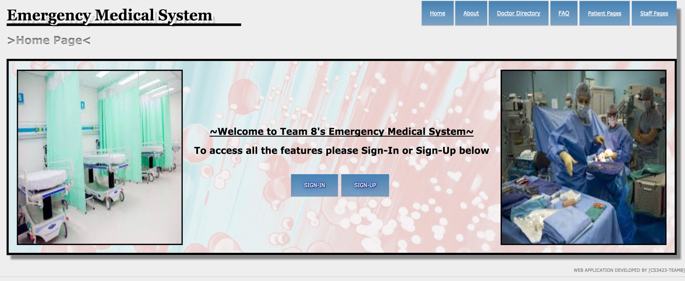

**HOMEPAGE**

**SIGN-IN OFF HOMEPAGE**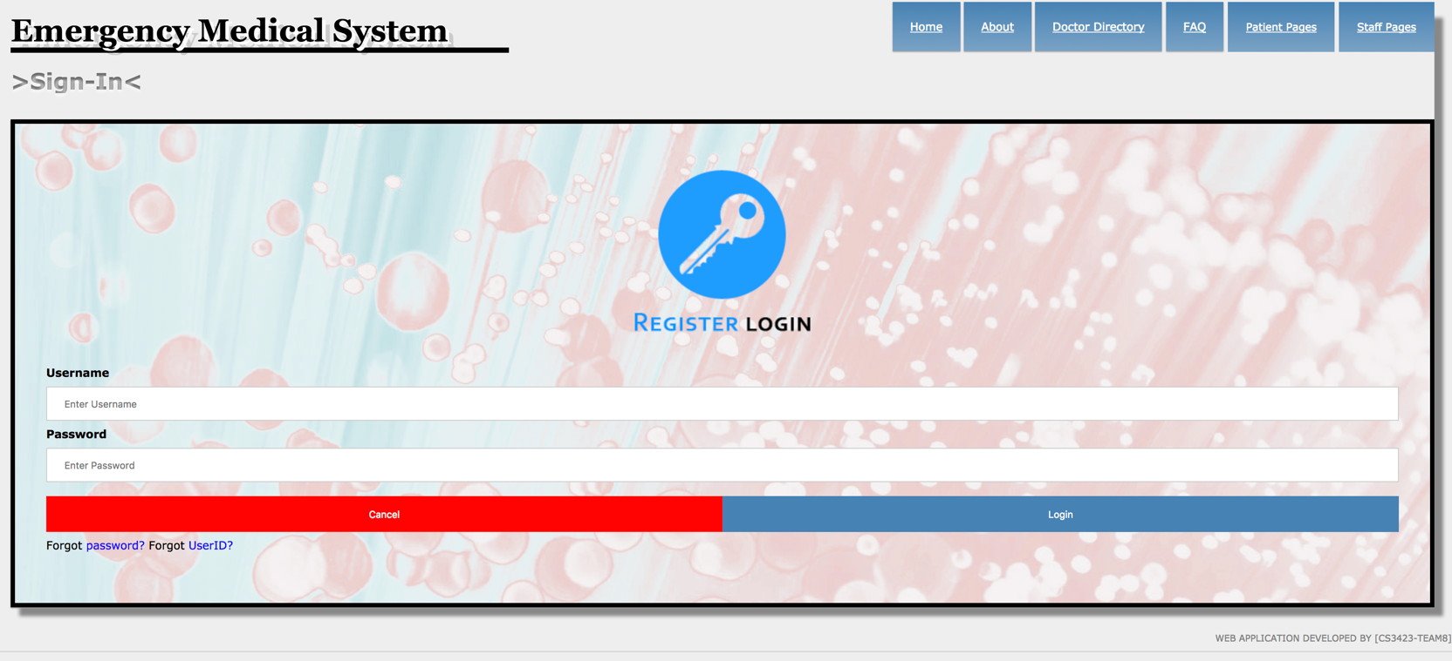

# data/control flow

# 

**SIGN-UP OFF HOMEPAGE**

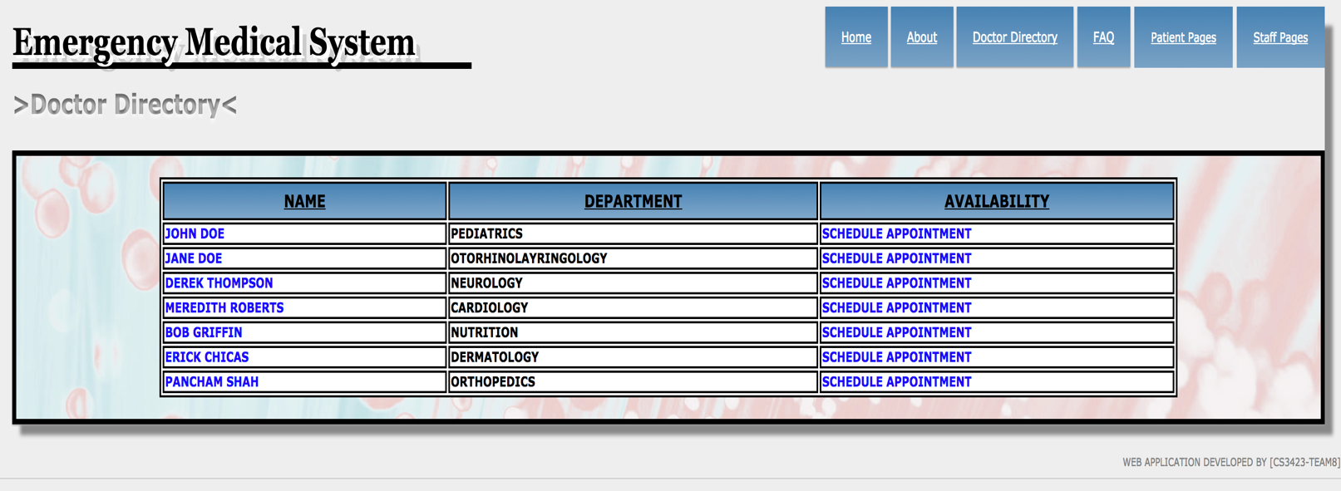**DOCTOR DIRECTORY PAGE UTILIZING NAV BAR**

# DATA/CONTROL FLOW

# 

**DOCTOR PROFILE PAGE UTILIZING EMBEDDED LINK IN DOCTOR DIRECTORY PAGE**

**FAQ PAGE UTILIZING NAV BAR WITH UTILIZATION OF HOVERS TO DISPLAY INFO**

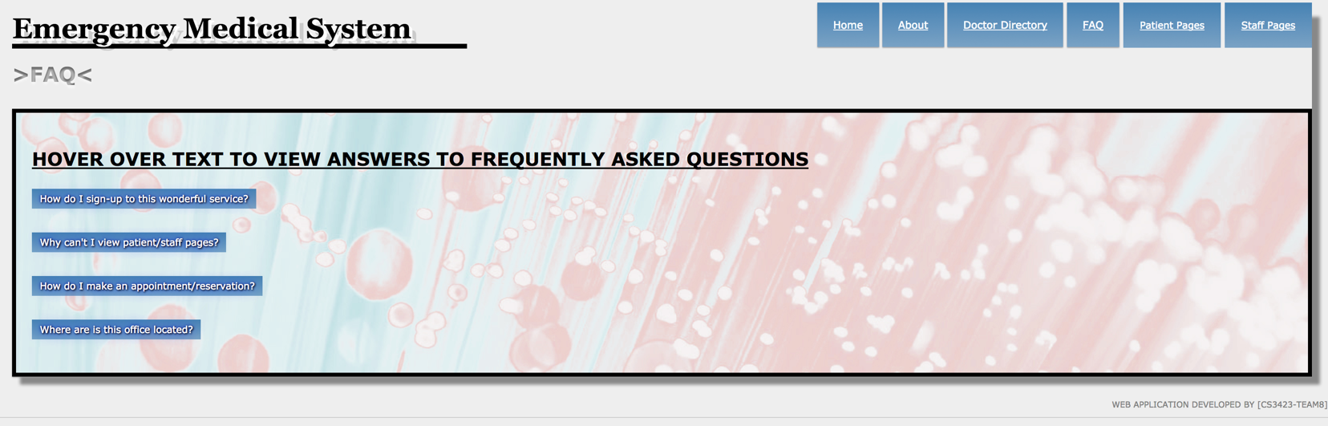

# data/control flow

# 

**DROPDOWNS TO ACCESS PATIENT/STAFF PAGES**

Overall data flow is fairly straight forward. Each image is a demonstration of the methods used, but not a complete look at the entire system as several pages utilize the same methods. As previously stated easy-of-use was a major objective, therefore through development the use of several methods to allow transitions were used to allow the system to flow smoothly.

# TEST CASES

1. User logs in with login and password.

2. User forgets password and clicks “Forgot Password.” Verifies Email and an email is sent

to reset password.

3. User forgets their ID. Clicks “Forgot ID”. Verifies Email and a new ID is sent via email.

4. User clicks new user. They enter their information. A user ID name is provided and sent via Email upon completion.

5. User (patient) clicks “change information”. User is allowed to change personal information such as insurance policy and name. (Anything else you can think of that can be changeable.)

6. User (Nurse) clicks “change patient information”. Allows for the Nurse to change height, weight, insert notes on their visit such as blood pressure and current medication they are taking.

7. User (Doctor) clicks “change patient information.” Same as nurse but allows more accept such as any procedures taken or care required.

8. User (Receptionist) logs in, can approve appointments

9. User (Patient) logs in then selects time and day for appointment.

10. User (Doctor) can request days off of work, vacation or none.

11. User(Patient) Make Payment Via insurance

12. User (Receptionist) can access total cost of visit and see what is due. They accept any

cash/check given by the patient. Accept Payment.

13. User(Patient) Access/Navigate Frequently Asked Questions Page

14. User (Patient) Access/Navigate Doctor Directory Page

15. User(Staff) Modify Frequently Asked Questions Page

16. User(Staff) Modify Doctor Directory Page

17. User (patient) tries to login but its invalid.

# Links

EMS LIVE LINK: <http://52.14.0.23/group8/index.html>

SOURCE CODE LINK: <https://github.com/mattking971/emsgroup8>